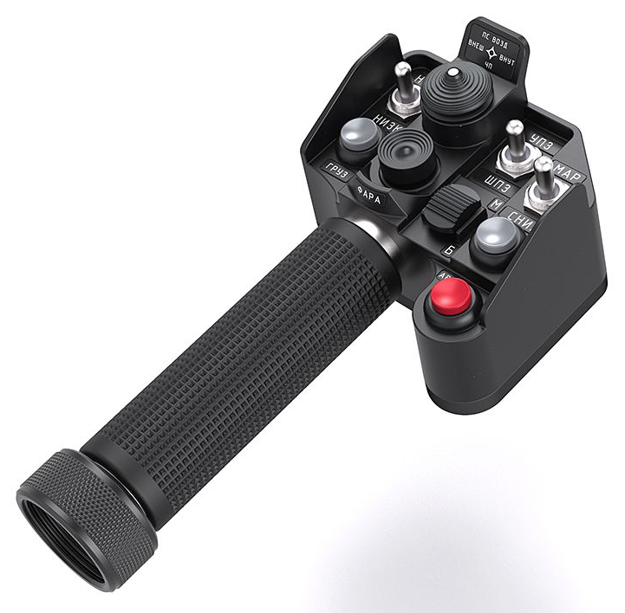
104 - Controls - Collective Grip SharKa-50
U=Up, D=Down, F=Forward, B=Backward, L=Left, R=Right, P=Press, S-*=Shift-*, L-*=Long-*

Top hat -- Autopilot
- F: Autopilot Pitch hold (toggle) (alternate for B2)
- B: Autopilot Altitude hold (toggle) (alternate for B5)
- L: Autopilot Heading hold (toggle) (alternate for B4)
- R: Autopilot Bank hold (toggle) (alternate for B1)
- P: Hover hold on/off
- S-B: Descent Mode button (when in hover hold, press and hold to safely descend at 2-3 m/s)
- S-P: Autopilot Flight Director mode (toggle) (turns off autopilot hold functions but leaves dampers on if roll and pitch channels are still on) (alternate for B3)
Bottom hat -- Shkval sensor
- F/B/L/R: Slew Shkval TV sensor
- P: Lock target (to unlock, press and hold while slewing in any direction)
Black 2-way switch -- Communications
- F: (SRS radio 1 PTT)
- B: (SRS radio 2 PTT)
- S-F: (SRS radio 3 PTT)
- P: (VoiceAttack PTT)
- S-P: (VoiceAttack center mouse cursor)
Metal 3-way switch 1 (left)
- F: Target frame size increase
- B: Target frame size decrease
- S-F: Turn to target
- S-B: A/A target
Metal 3-way switch 2 (middle)
- F: Narrow view (23x)
- B: Wide view (7x)
- S-F: A/A head-on
- S-B: Ground moving target
Metal 3-way switch 3 (right)
- F: Helmet-Mounted Sight on/off (or NVG if fitted instead)
- B: Targeting system reset button (turns off Shkval and sets HUD to nav mode; if cannon is still selected, some cannon symbology will remain)
- S-F: Engine dust/de-icing switch cycle
White button 1
- P: Countermeasures Start dispensing (default program is 1 flare only)
- S-P: Countermeasures Stop dispensing
White button 2
- P: --??
Red button
- P: Uncage Shkval, designate target (if using HMS, press and hold, look at target, then release; if not using HMS, sets Shkval on automatic left/right scan)
- S-P: Laser designator armed/safe

